Java Lab Assignment

Name: Om Ashish Mishra

Registration Number: 16BCE0789

Slot: G2

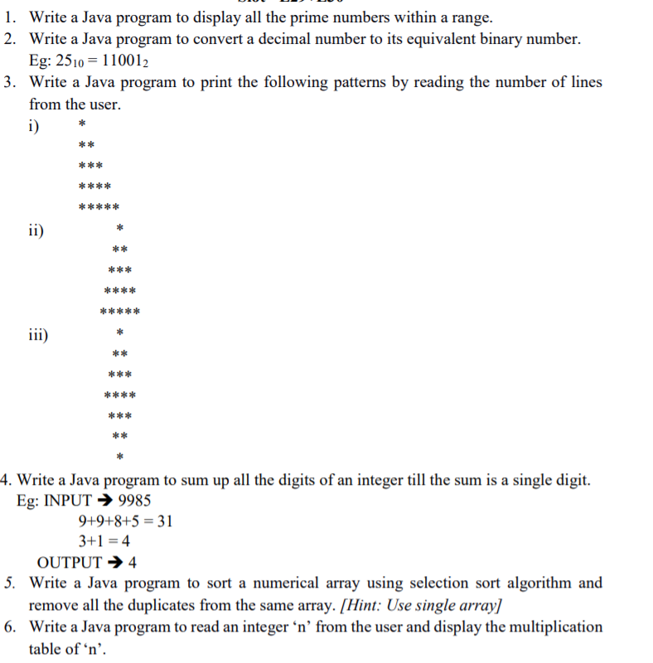

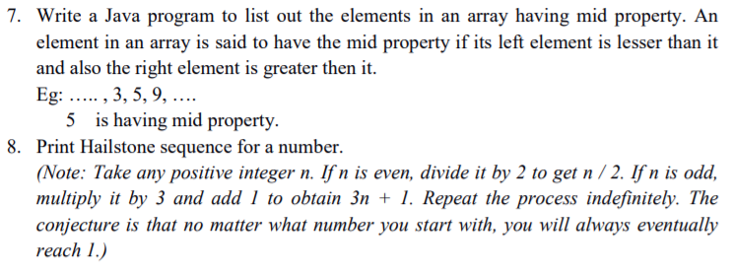

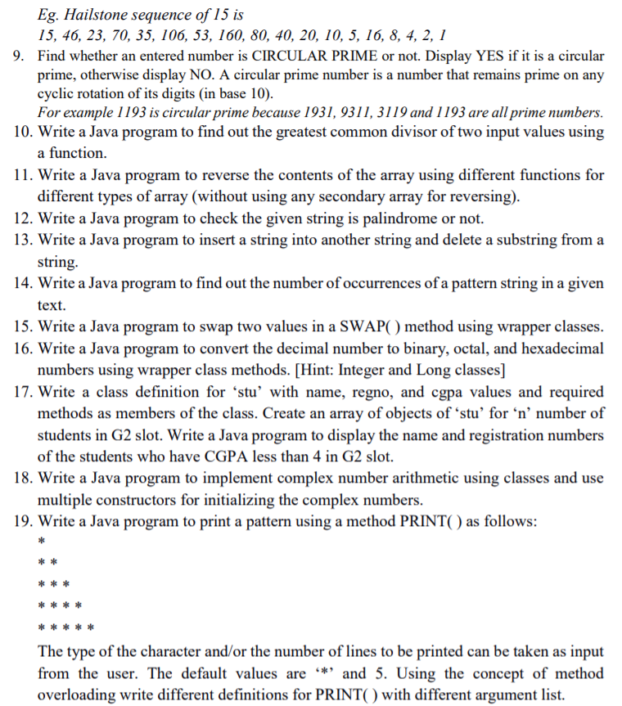

The Answer:

The answers:

1.

The Code:

package javaapplication1;

import java.util.\*;

/\*\*

\*

\* @author 16BCE0789

\*/

public class JavaApplication1 {

public static void main(String args[])

{

Scanner sc = new Scanner(System.in);

int a,b,k=0;

a = sc.nextInt();

b = sc.nextInt();

for(int i = a;i<=b;i++)

{

for(int j = 2;j<=a/2;j++)

{

if(i%j==0)

{

k=1;

break;

}

}

if(k==0)

System.out.println(i);

k=0;

}

}

}

The Output:

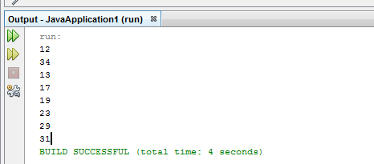

The first two numbers are the range end points. 12 and 34 in this case.

2.

package javaapplication1;

import java.util.\*;

/\*\*

\*

\* @author 16BCE0789

\*

\*

\*/

public class JavaApplication1 {

public static void main(String args[])

{

Scanner sc = new Scanner(System.in);

int a,k=0;

a = sc.nextInt();

int m =a;

//b = sc.nextInt();

String b = "";

while(a!=0)

{

int r = a%2;

b = r+b;

a=a/2;

}

System.out.println("The binary Format is "+b);

}

}

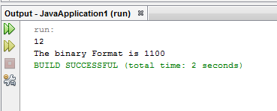

3.

First Pattern program:

package javaapplication1;

import java.util.\*;

/\*\*

\*

\* @author 16BCE0789

\*

\*

\*/

public class JavaApplication1 {

public static void main(String args[])

{

Scanner sc = new Scanner(System.in);

int a,b,k=0;

a = sc.nextInt();

//b = sc.nextInt();

for(int i = 1;i<=a;i++)

{

for(int j = 1;j<=i;j++)

{

System.out.print("\*");

}

System.out.println("\n");

}

}

}

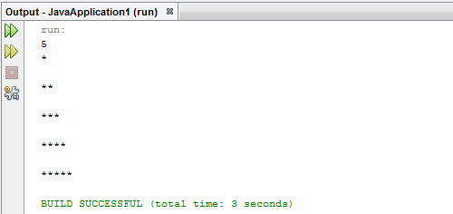

Second Pattern Program:

package javaapplication1;

import java.util.\*;

/\*\*

\*

\* @author 16BCE0789

\*

\*

\*/

public class JavaApplication1 {

public static void main(String args[])

{

Scanner sc = new Scanner(System.in);

int a,b,k=0;

a = sc.nextInt();

int m =a;

//b = sc.nextInt();

for(int i = 1;i<=a;i++)

{

for(int k1 = m-1;k1>0;k1--)

{

System.out.print(" ");

}

for(int j = 1;j<=i;j++)

{

System.out.print("\* ");

}

System.out.println("\n");

m--;

}

}

}

The Output:

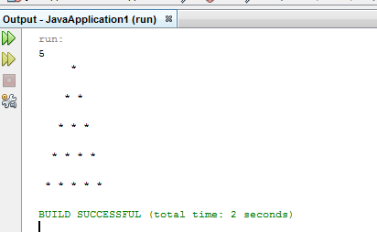

Thrid pattern

package javaapplication1;

import java.util.\*;

/\*\*

\*

\* @author 16BCE0789

\*

\*

\*/

public class JavaApplication1 {

public static void main(String args[])

{

Scanner sc = new Scanner(System.in);

int a,b,k=0;

a = sc.nextInt();

int m =a;

//b = sc.nextInt();

for(int i = 1;i<=a;i++)

{

for(int k1 = m;k1>0;k1--)

{

System.out.print(" ");

}

for(int j = 1;j<=i;j++)

{

System.out.print("\* ");

}

System.out.println("\n");

m--;

}

m=1;

for(int i = a-1;i>0;i--)

{

for(int k1 = 0;k1<=m;k1++)

{

System.out.print(" ");

}

for(int j = 1;j<=i;j++)

{

System.out.print("\* ");

}

System.out.println("\n");

m++;

}

}

}

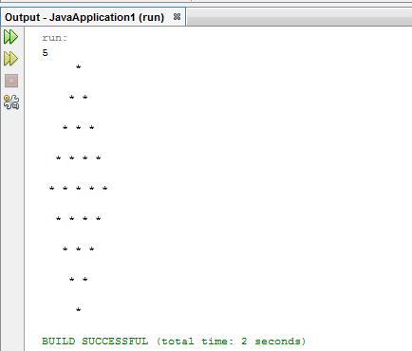

4.

8.

package om2;

import java.util.\*;

/\*\*

\*

\* @author 16BCE0789

\*/

public class Om2 {

public static void main(String args[])

{

Scanner sc = new Scanner(System.in);

int n,b,k=0;

n = sc.nextInt();

System.out.print(n);

while(n!=1)

{

if(n%2==0)

n=n/2;

else

n=3\*n+1;

System.out.print(", "+n);

}

System.out.println();

}

}

The output:

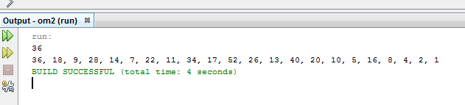

9.

package om2;

import java.util.\*;

import java.lang.\*;

/\*\*

\*

\* @author 16BCE0789

\*/

public class Om2 {

public static void main(String args[])

{

Scanner sc = new Scanner(System.in);

int n,s=0,b,k=0;

n = sc.nextInt();

int[] arr = new int[10];

int[] b1 = new int[10];

int d = n;

while(d!=0)

{

s=s+1;

d/=10;

}

for(int i = 0;i<s;i++)

{

double x = n/Math.pow(10,s-1);

double y = n%Math.pow(10,s-1);

double g = y\*10+x;

arr[i]=(int)g;

n = (int) g;

}

for(int i = 0;i<s;i++)

{

for(int j = 2;j<=arr[i]/2;j++)

{

if(i%j==0)

{

k=1;

break;

}

}

if(k==0)

continue;

k=0;

}

if(k==0)

{

System.out.println("The Number is Circular Prime");

}

else

{

System.out.println("The Number is not Circular Prime");

}

}

}

The Output:

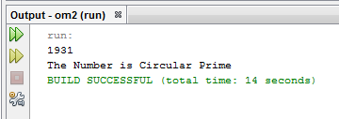

10.

package om2;

import java.util.\*;

import java.lang.\*;

/\*\*

\*

\* @author 16BCE0789

\*/

public class Om2 {

public static void main(String args[])

{

Scanner sc = new Scanner(System.in);

int a,s=0,c,b,k=0;

System.out.print("Enter the first Number : ");

a = sc.nextInt();

System.out.println("Enter the Second Number : ");

b = sc.nextInt();

a = a>b?a:b;

System.out.println("The Highest Number is : "+a);

b = a>b?b:a;

System.out.println("The Lowest Number is : "+b);

if(a%b==0)

{

System.out.println("The GCD is : "+b);

}

else

{

while(a%b!=0 || b!=1)

{

c = a%b;

a=b;

b=c;

}

System.out.println("The GCD is : "+c);

}

}

}

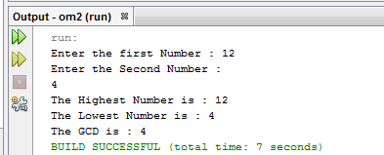

11.

package javaapplication2;

import java.io.\*;

import java.util.\*;

import java.lang.String;

/\*\*

\*

\* @author 16BCE0789

\*/

public class JavaApplication2 {

/\*\*

\* @param args the command line arguments

\*/

static int a[] = new int[10];

static String b[] = new String[10];

static void Number(int a[],int n)

{

int i,j=n-1;

for(i=0;i<n/2;i++)

{

int tmp = a[i];

a[i]=a[j];

a[j]=tmp;

j--;

}

System.out.println("The Elements after the swapping : ");

for(i=0;i<n;i++)

{

System.out.println(a[i]+"\t");

}

}

static void Characters(String a[],int n)

{

int i,j=n-1;

String tmp="";

for(i=0;i<n/2;i++)

{

strcpy(tmp,a[i]);

strcpy(a[i],a[j]);

strcpy(a[j],tmp);

}

System.out.println("The Elements after the swapping : ");

for(i=0;i<n;i++)

{

System.out.println(a[i]+"\t");

}

}

public static void main(String[] args) {

// TODO code application logic here

Scanner sc = new Scanner(System.in);

System.out.println("Enter your Choice 1. for Number or decimal type and 2. for Strings");

int ch = sc.nextInt();

if(ch==1)

{

System.out.println("Enter the number of elements : ");

int n = sc.nextInt();

System.out.println("Enter the elements : ");

for (int i =0;i<n;i++)

{

a[i]=sc.nextInt();

}

System.out.println("The lements of the array before swapping : ");

for(int i = 0;i<n;i++)

{

System.out.print(a[i]+"\t");

}

Number(a,n);

}

else if(ch==2)

{

System.out.println("Enter the number of elements : ");

int n = sc.nextInt();

System.out.println("Enter the elements : ");

for (int i =0;i<n;i++)

{

b[i]=sc.nextLine();

}

System.out.println("The lements of the array before swapping : ");

for(int i = 0;i<n;i++)

{

System.out.print(b[i]+"\t");

}

Characters(b,n);

}

}

}

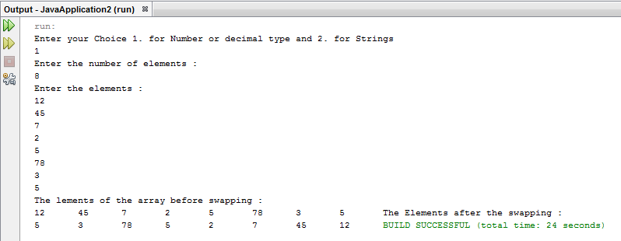

12.

package javaapplication2;

import java.io.\*;

import java.util.\*;

import java.lang.String;

/\*\*

\*

\* @author 16BCE0789

\*/

public class JavaApplication2 {

public static void main(String[] args) {

Scanner sc = new Scanner(System.in);

System.out.println("Enter Your String");

String s = sc.nextLine();

int n = s.length();

String s1 = "";

for(int i = n-1;i>=0;i--)

{

s1=s1+s.charAt(i);

}

if(s.equalsIgnoreCase(s1))

{

System.out.println("The String is Palindrome");

}

else

{

System.out.println("The String is not Palindrome");

}

}

}

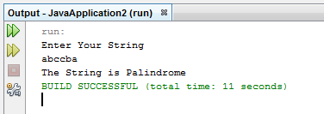

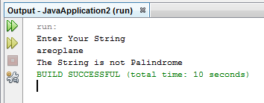

13.

package javaapplication2;

import java.io.\*;

import java.util.\*;

import java.lang.String;

/\*\*

\*

\* @author 16BCE0789

\*/

public class JavaApplication2 {

public static void main(String[] args) {

Scanner sc = new Scanner(System.in);

System.out.println("Enter the String : ");

String s = sc.nextLine();

System.out.println("Enter your choice 1. for insertion and 2. for deletion");

int ch = sc.nextInt();

int n = s.length();

if(ch==1)

{

System.out.println("Enter the String you want to insert : ");

String s1 = sc.nextLine();

System.out.println("Enter the position of insertion : ");

int h = sc.nextInt();

String d = "";

for(int i = 0;i<n;i++)

{

if(i==(h-1))

{

d = d+s1;

}

else

{

d = d+s.charAt(i);

}

}

System.out.println("The Original String : "+s);

s = d;

System.out.println("The String After the Inserting is : "+s);

}

else if(ch==2)

{

System.out.println("Enter the substing to be delected : ");

String s2 = sc.nextLine();

}

}

}